Zoom integration
Installation:
- In order to create a meeting, it is necessary to use a Zoom account or Google/Facebook account related to a Zoom account and authorize RLP APP:
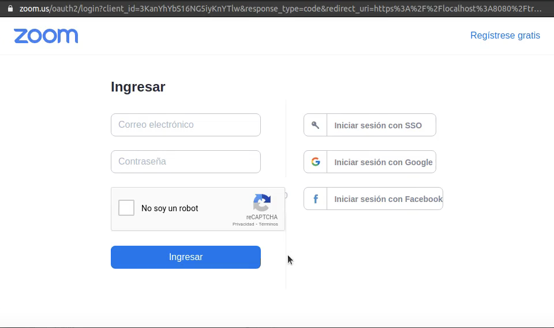

- Using your Zoom account:
- Login using your Zoom account.
- Click on authorize.
- The meeting will be created.

- Using your Gmail account:
- Login using your Gmail account.
- *Follow the Gmail instructions to create a Zoom account related to your Gmail account.
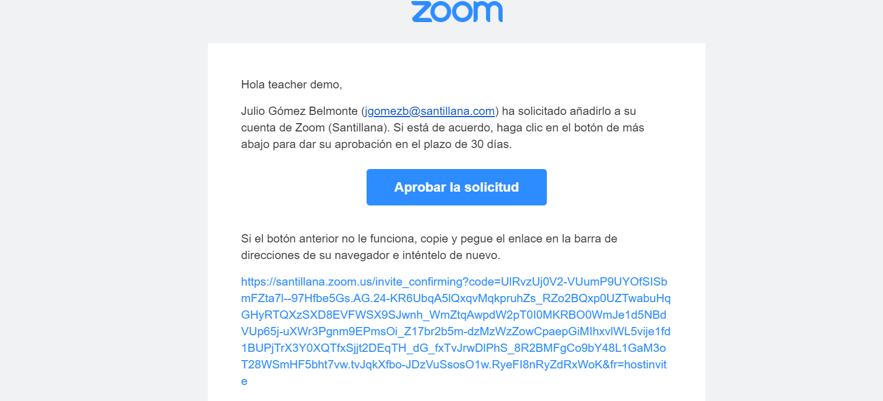

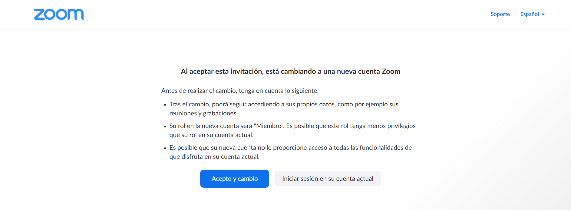
- The meeting will be created.

- Using your Facebook Account
- Login using your Facebook user and password
- *Follow the Facebook instructions to create a Zoom account related to your Facebook account.
- Click on authorize.
- The meeting will be created.
*You will have to make these settings if you do not already have a Zoom account.

Usage:
- How to create a meeting:
Teachers will have to create a meeting by following these steps:
- Go to the class where you want to create the zoom class.

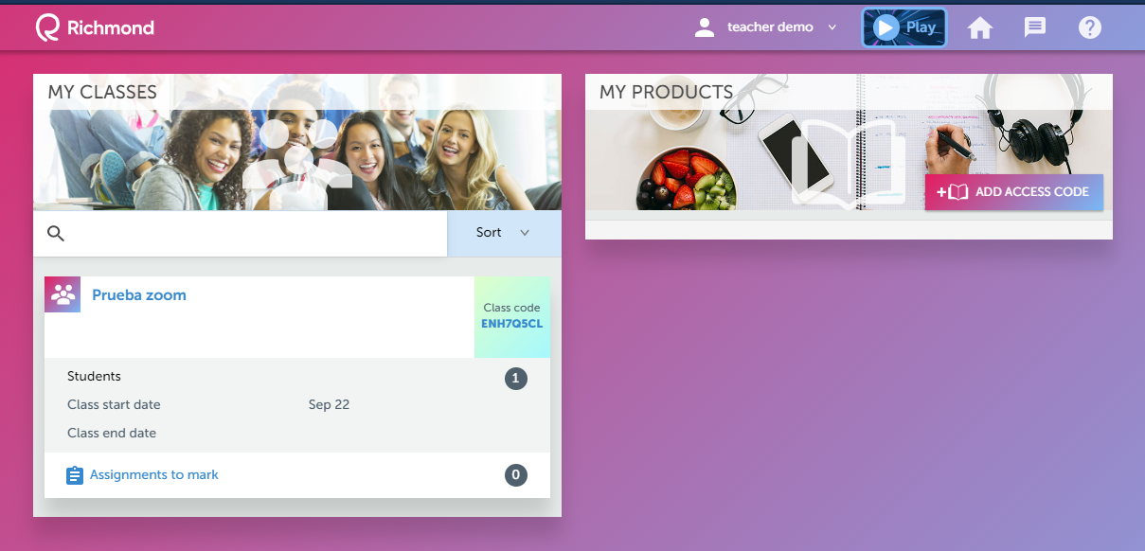

- Click on the communications icon.
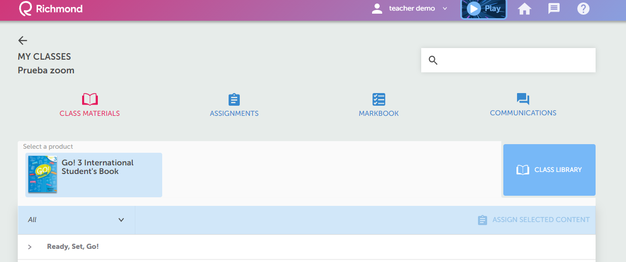
- Select the tab My Online Classes

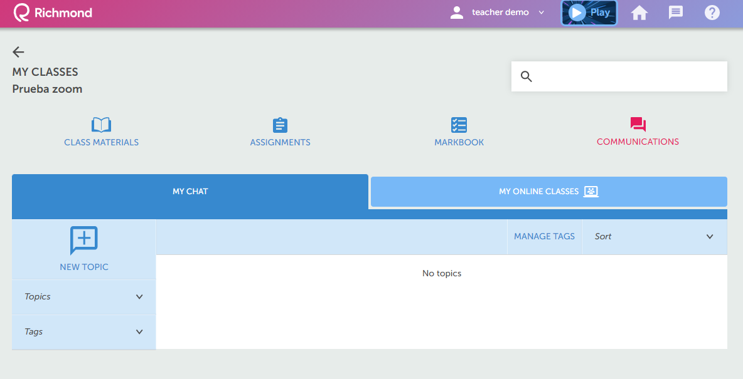

- You will need to create a new Online class by selecting the NEW ONLINE CLASS BUTTON
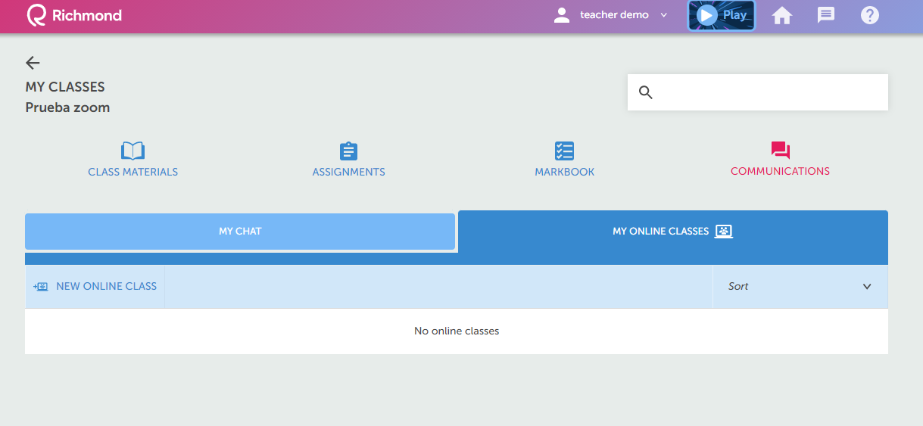
- You will be presented the following menu

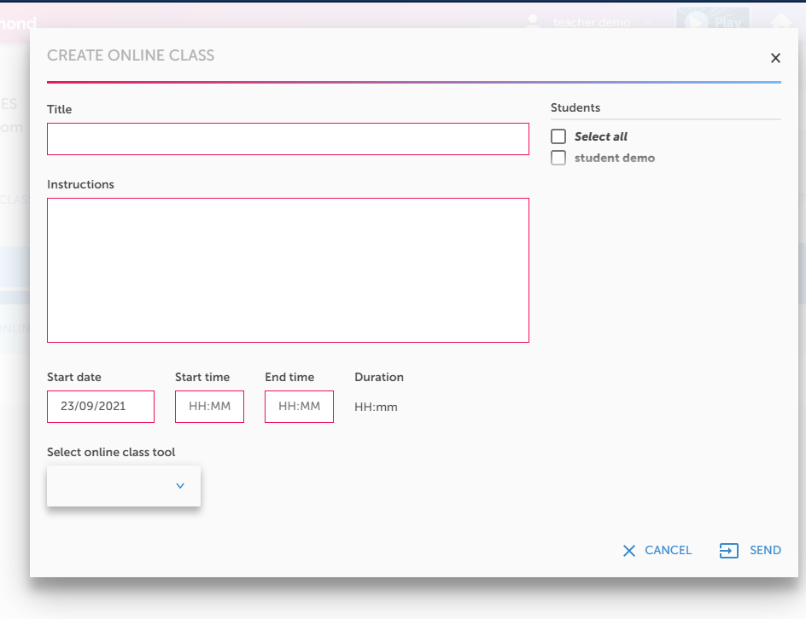
- You will need to fill out the following information:
Title: This is the name for the class, you can include the topic of the class in this box.
Instructions: These are the recommendations for the class, the students will be able to read it in order to get more information about the work to be done in the class.
Star date: This is the date in which the class is going to take place
Start time: This is the time at which the class is going to start on the selected date
End time: This is the time at which the class is going to end on the selected date.
Select online class tool: Here you will select from the drop down list the zoom option.

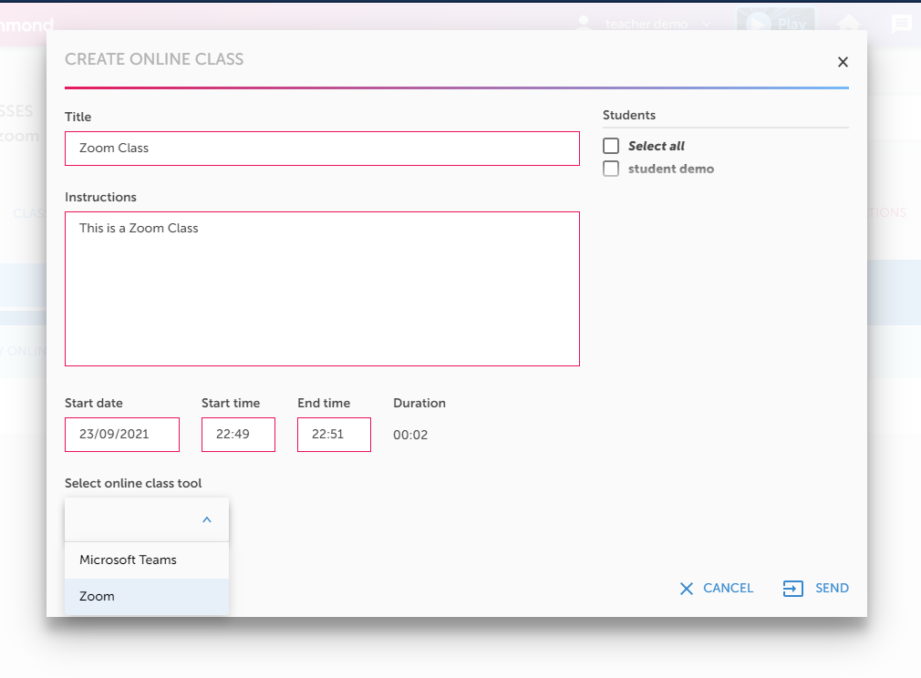
- After completing all the required information, you need to select the students that will be invited to the class on the top right corner and after doing so, you need to click send on the bottom right corner to send the invitation.
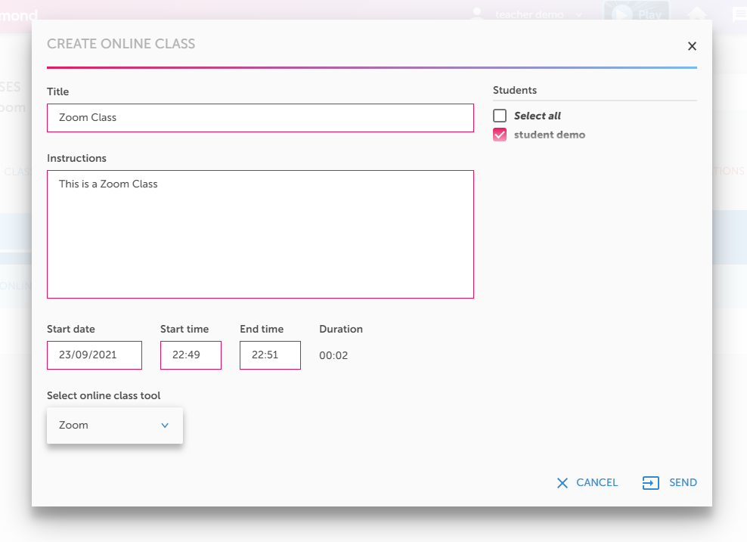
RLP will redirect to Zoom where teachers will have to log in using their Zoom users or using their Google/Facebook accounts. Once they have logged in successfully, the Zoom meeting will be created:

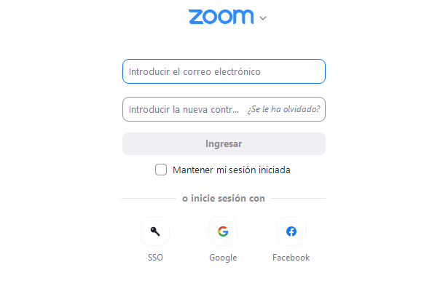
- After completing all the steps, you will see the scheduled zoom class. The invitation will be sent automatically to the students previously selected.

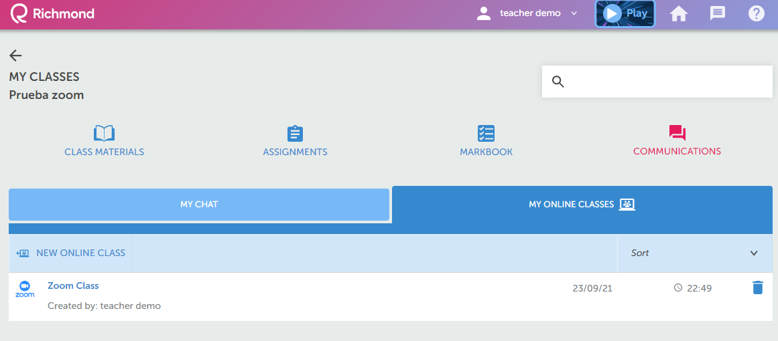

- When the time to start the class is up, as a teacher you only need to click on the zoom class logo, this will launch the zoom application automatically.

STUDENTS

1. When a zoom class has been scheduled by a teacher, students will have to go to my communications icon and select My Online Classes Tab.

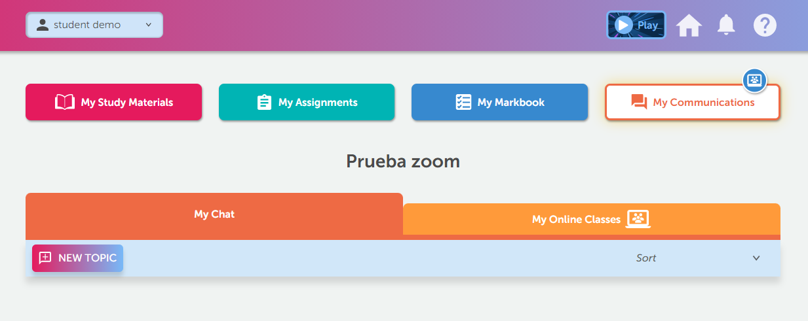

2. As a student you will need to click on the start button once the time is up and the application will be launched automatically

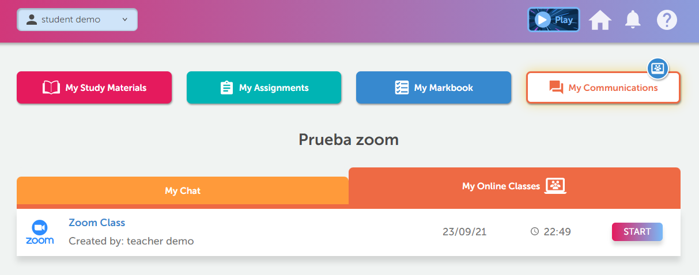

Uninstalling the Gmail Add-on:
- Login to your Zoom Account and navigate to the Zoom App Marketplace.
- Click Manage > Installed Apps or search for the Gmail app.
- Click the Gmail app.
- Click Uninstall.

Contact Support: https://confluence.project-tools.santillanatn.com/prlp

